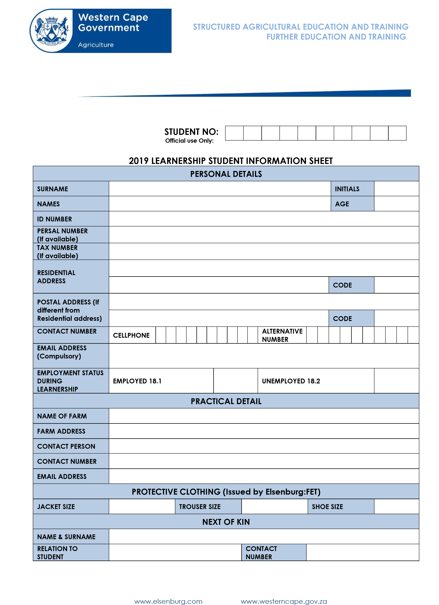

**2023 LEARNERSHIP STUDENT INFORMATION SHEET**